

Department of Information and Communication Technology
Faculty of Technology
University of Ruhuna

Database Management Systems Practicum
ICT 1222
Assignment 02 – Mini Project
Group Number 16

Submitted to: Mr.P.H.P. Nuwan Laksiri

Submitted by: TG/2023/1721 - P.H.T.Sharindi
TG/2023/1781 - H.G.D.I.Shadeep
TG/2023/1748 - R.P.D.Radeeshan

Contents

- Brief introduction about the problem/group project 3
- Brief introduction to the solution 4
- Proposed ER/EER diagram 5
- Proposed Relational mapping diagram 6
- Table structure of our solution 7
- Architecture of our solution 11
- Tools and technologies that have been used 12
- Security measures that you have taken to protect our DB 12
- Brief description about DB Accounts/Users and the reasons for creating 13
- Code snippets to support our work(Stored procedures/views, etc) 14
- Problems that we faced during the development of the solution 34
- Solutions/how we have overcome the above identified problems 34
- Choose a platform for the host database and reason 34
- The things/changes to do for the host database in cloud storage 35
- Individual contribution to the backend development 36
- References 42

- Brief Introduction to the Problem/group project

A faculty of technology needs a system to manage all student information. The main problems are tracking student details, student marks, student attendance and result management.
This task is difficult to do manually. We need to store various scores (like quizzes and final exam scores) and check who is eligible for the final exam. All the results must follow the rules prescribed by UGC Circular No. 12-2024. We need a good system to avoid errors and keep the data safe.

In a manual system, teachers spend too much time adding marks and checking attendance percentages. Also, students cannot easily check their own attendance or final marks quickly.
Also, it is very difficult to create important reports like SGPA and CGPA for everyone.
So as summary, we need to create a solution for a problem like this.

- Brief Introduction to the Solution

The solution is for this problem is develop a Database Management System. By This system it will automatically manage and calculate all data of the faculty.

By this solution, it,
- Store all data: Keep all student details, user details, marks, and attendance records, etc.

- Track attendance: Record students' attendance for both theory and practical sessions. It can also record when a student submits a medical note.

- Manage users by setting up separate accounts for various roles, including Admin, Dean, Lecturer, Technical Officer, and Student. Each account type will have only the required access.

- Calculate results: Automatically calculate eligibility for the final exam. Then, it will calculate the student’s final grade, SGPA, and CGPA using UGC rules.

- This system helps manage student academic data easily and securely for the entire faculty.

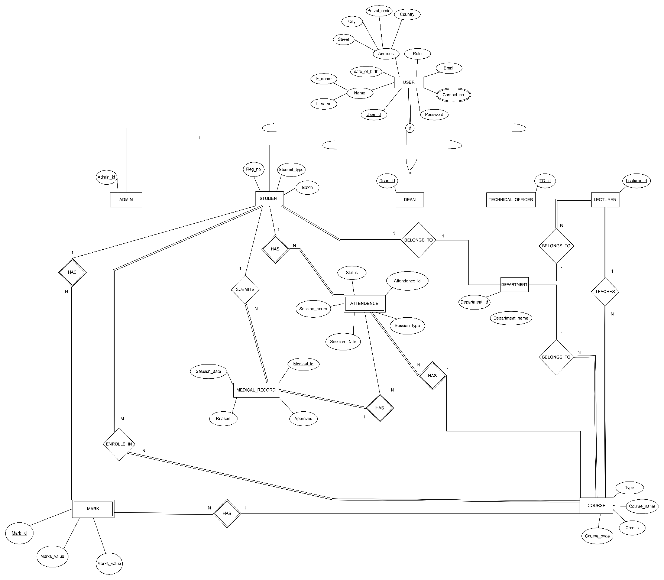
- Proposed ER/EER diagram

- Proposed Relational mapping diagram
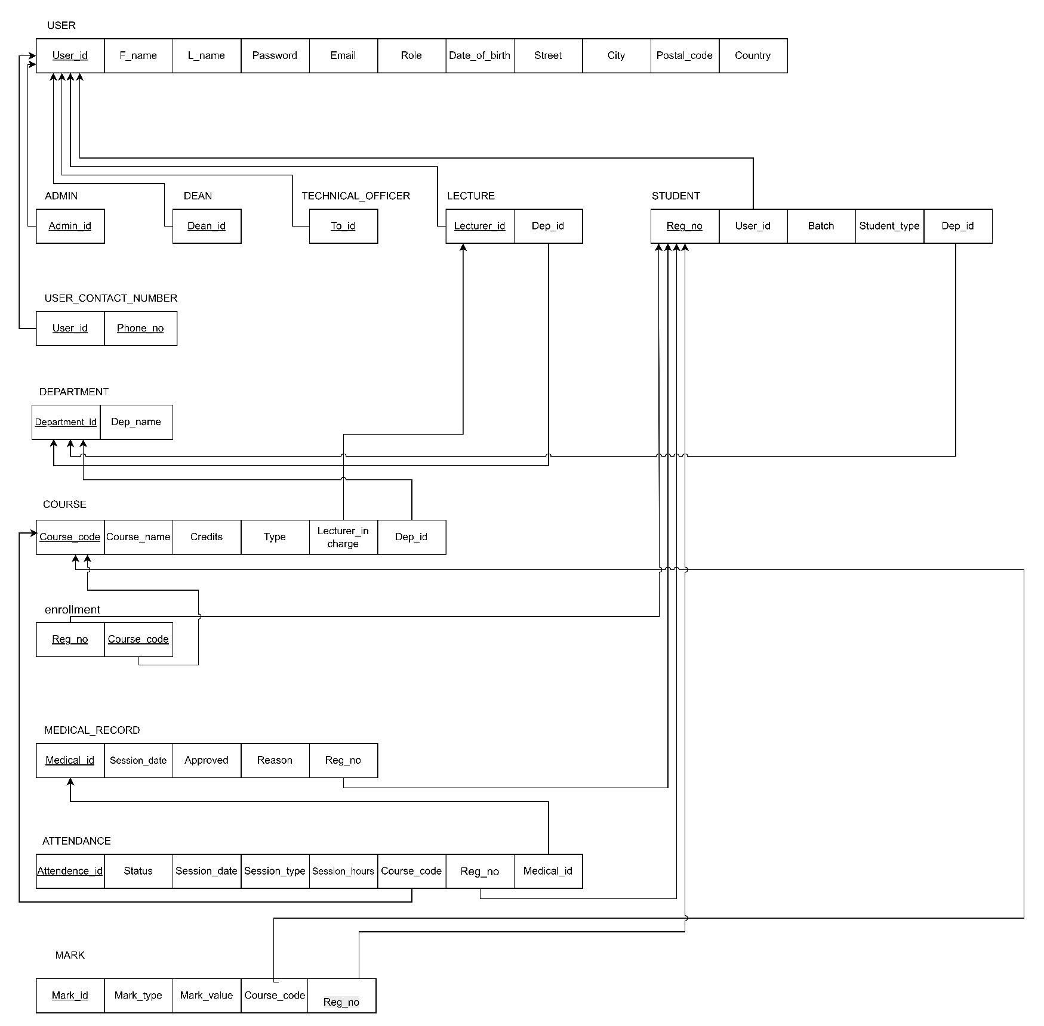

- Table structure of solution

User table –
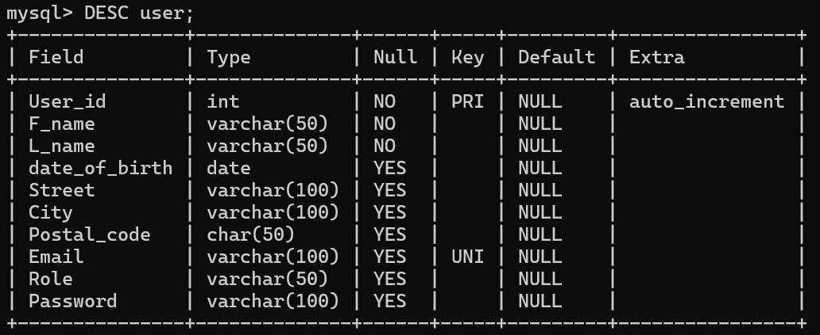

Dean table -
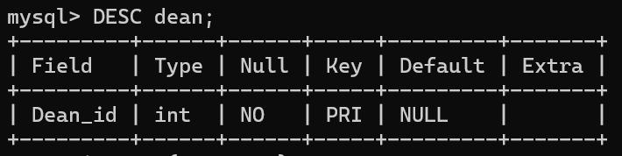

Admin table -
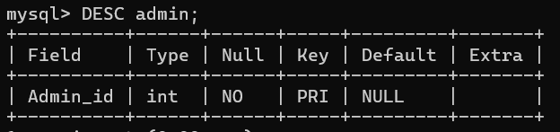

Technical officer table-
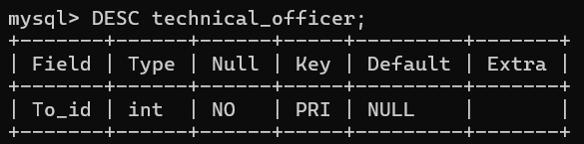

Student table-
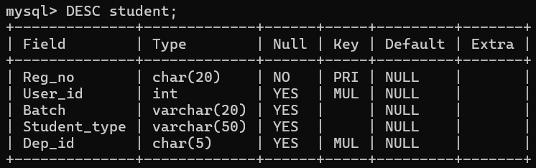

Lecture table -
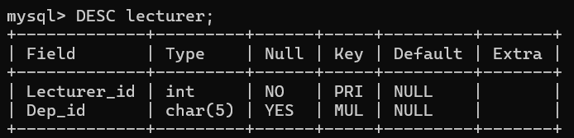

Attendance table-
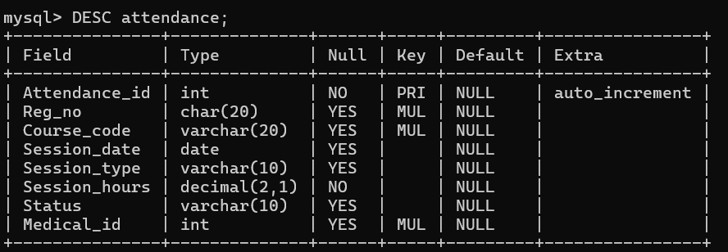

Course table-
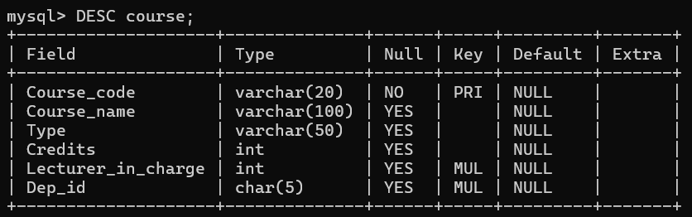

Deparment table-
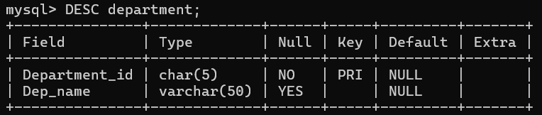

Enrollment table -
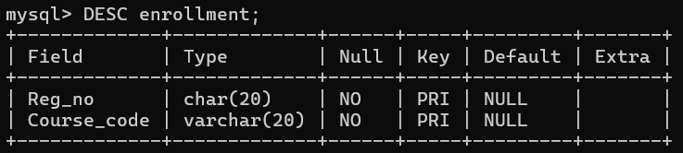

Mark table -
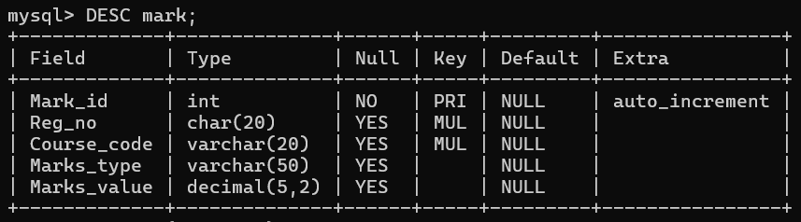

Medical_record table -
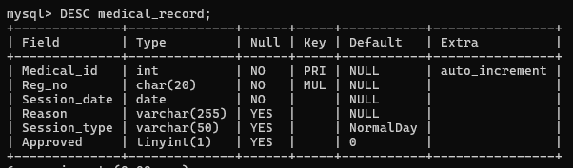

User contact number table -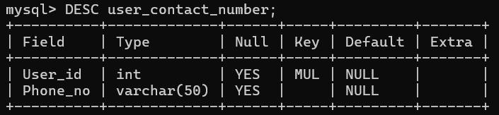
- Architecture of our solution

The architecture of our solution is a tier architecture. This structure is mainly based on three tires.

They are,
- Presentation Tier (The Screen) –
- This is the part of the solution that user sees. This tier shows data and takes our requests.

- Application Tier (The Brain) –
- This is the middle layer of the solution that all rules and logic runs.all conditions are run in this layer.

- Data Tier (The Storage) -
- This is the database that contains all information. This layer securely stores all data.

With this architecture, we can create a better solution.

- Used Tools and technologies

    - Draw.io - Used to create the EER diagram and Relational schema.
    - MYSQL server, VSCode – for writing structure, query, and other things.
    - MS Word – for creating a report.
    - GitHub – for version control and collaborating with group members.

- Security measures that you have taken to protect DB

- Access control –
  - Create different user accounts with special permissions
Like,
Students can only look at (read) their final marks. They cannot change them.
Technical Officers can only read, change, or update attendance records.
Lecturers can work with most data but cannot create new user accounts.
Only the Admin user has all the power to do everything.

- Use views –
  - By views can show exactly the data that the user needs without displaying all information.

- Brief description about DB Accounts/Users and the reasons for creating

- Lecturer
- Can manage course content and student marks.
- Can enter and update assessment marks.
- Can view student attendance for their courses.

- Technical Officer
- Specifically manages attendance records.
- Can read, add, and update attendance data.
- Cannot access marks or personal student information.

- Student
- Can only view their own final attendance and grades.
- Cannot modify any data in the system.
- Can check their academic progress and eligibility status.

- Admin
- Has full control over the entire database system.
- Responsible for creating and managing all user accounts.
- Can modify any table, view, or database structure.
- Dean
- Can view and modify all academic data.
- Cannot create or manage user accounts.
- Can generate reports and review student progress.

Reason is to create that various types of user accounts with different permission is for better control and better security of database. otherwise, it is can control everyone for their own needs.

- Code snippets to support our work

- List of All views
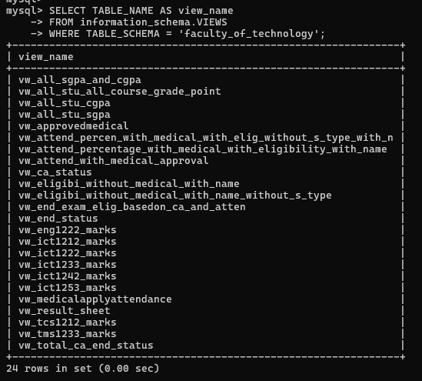

  - views

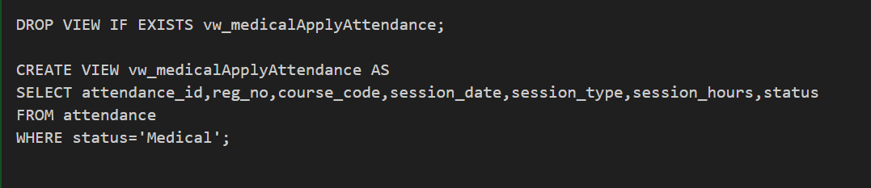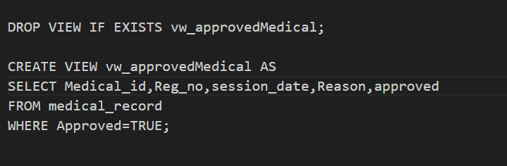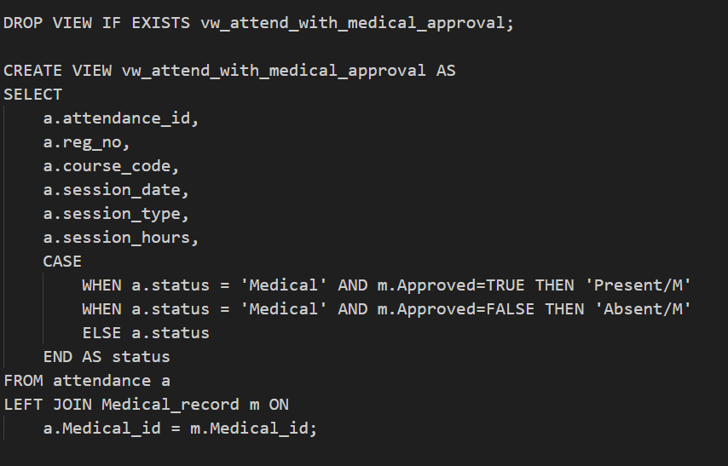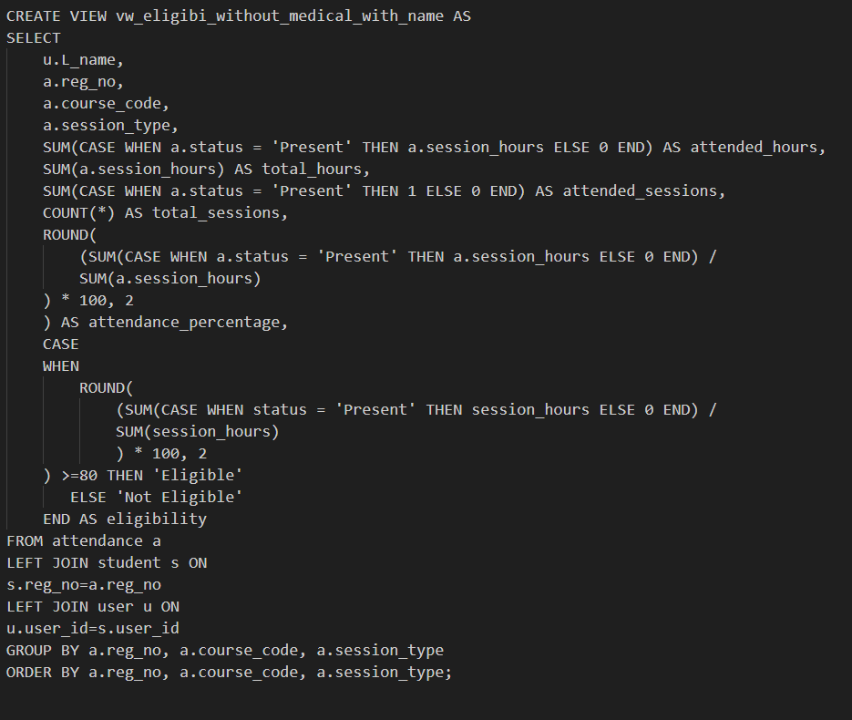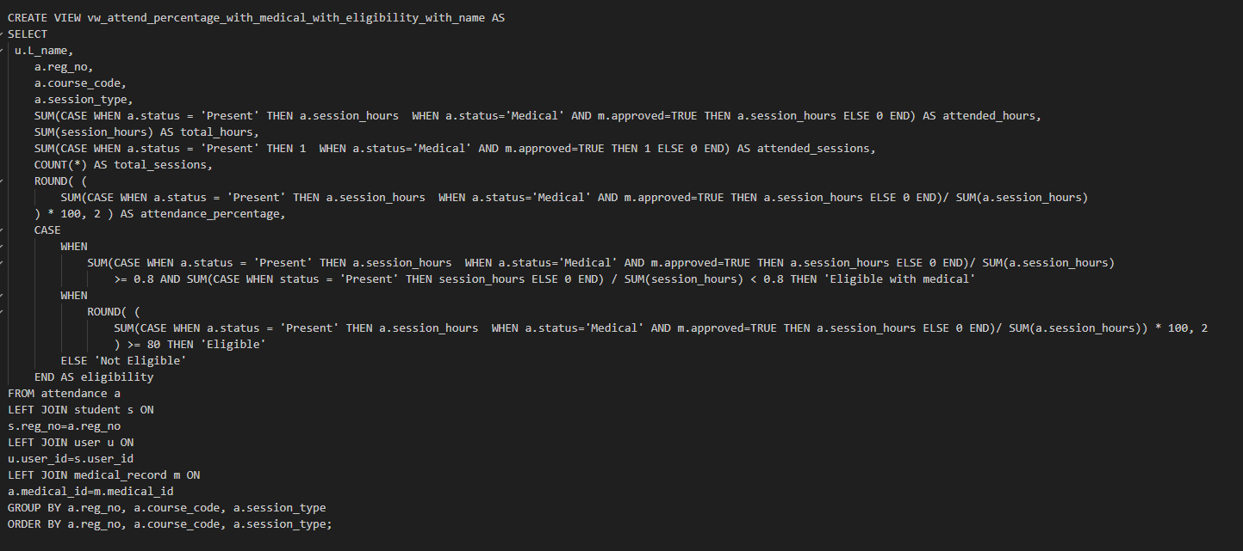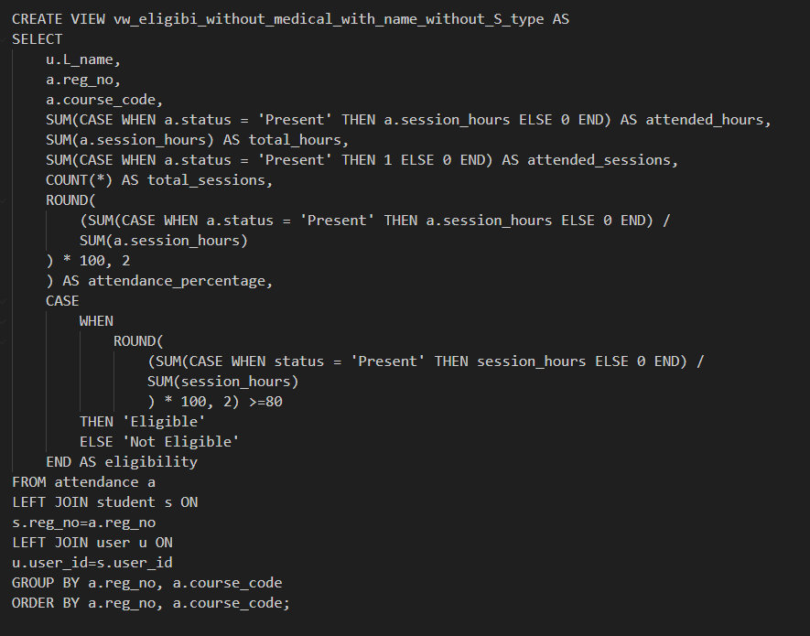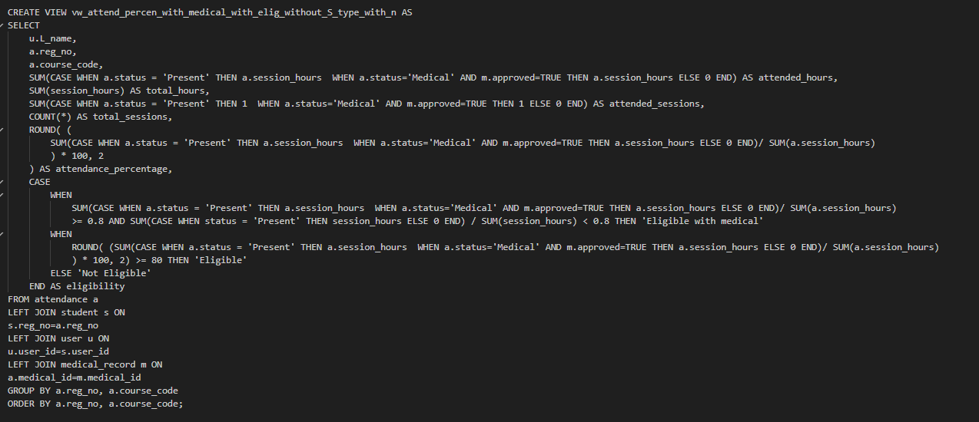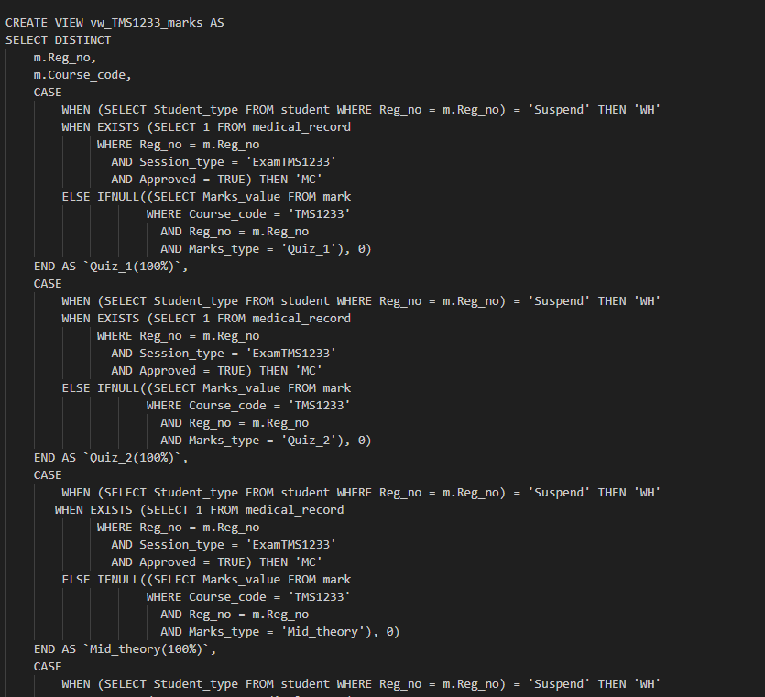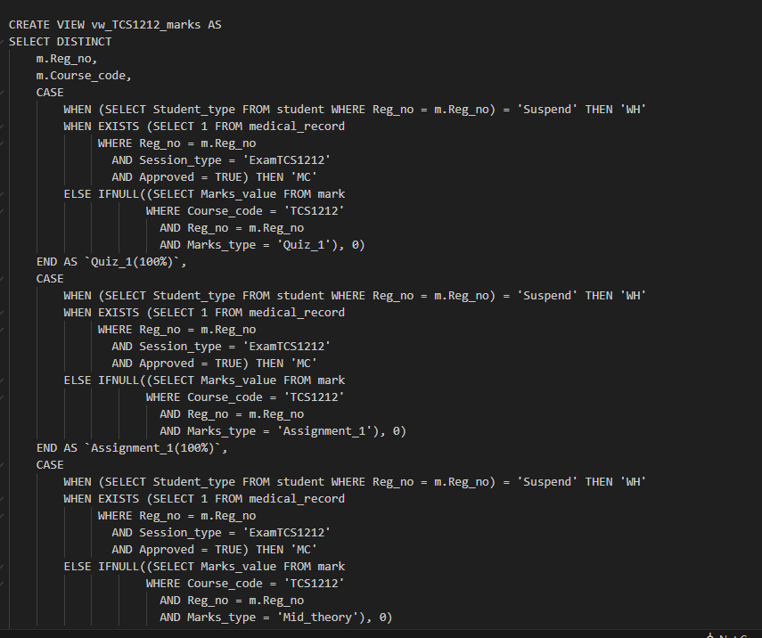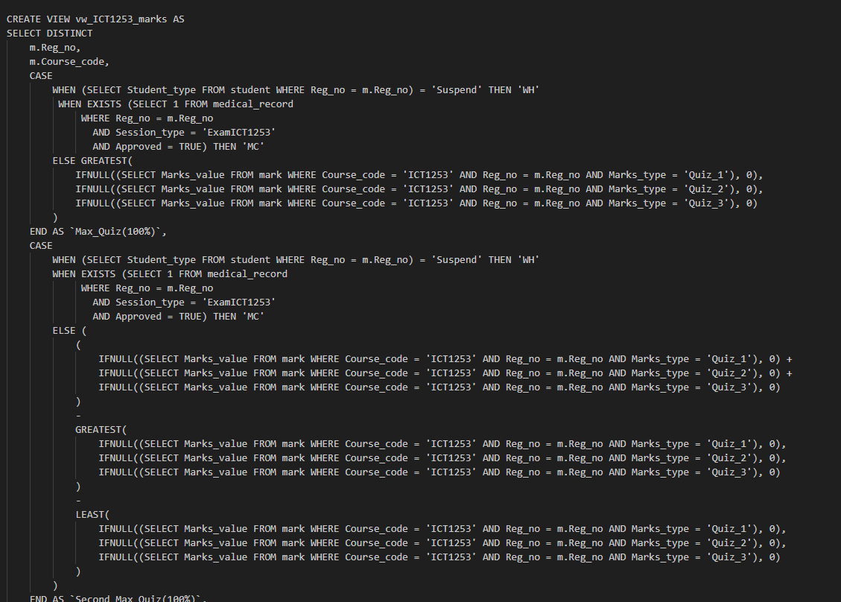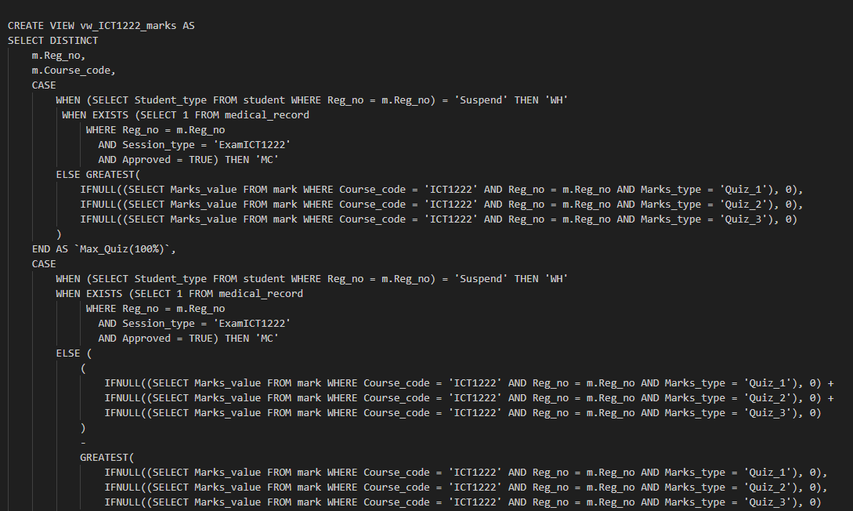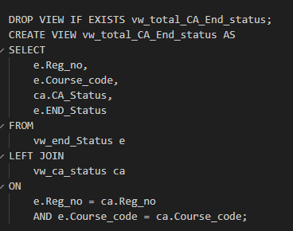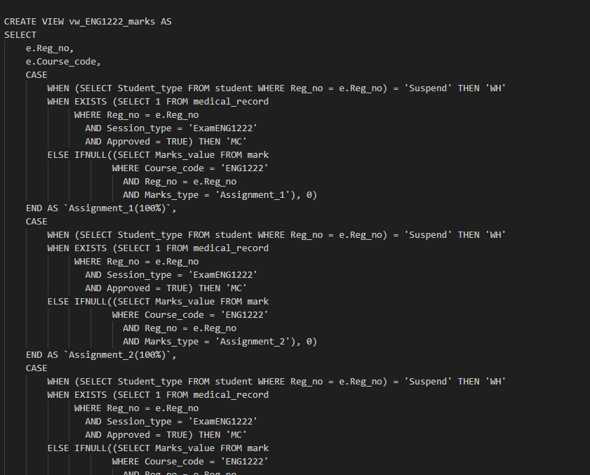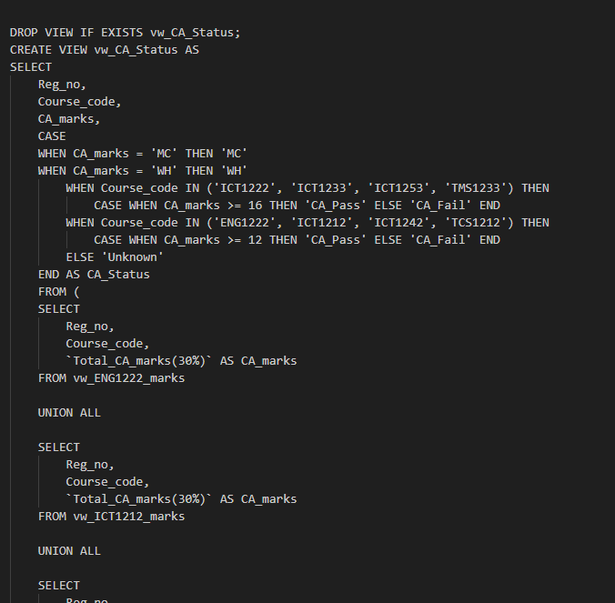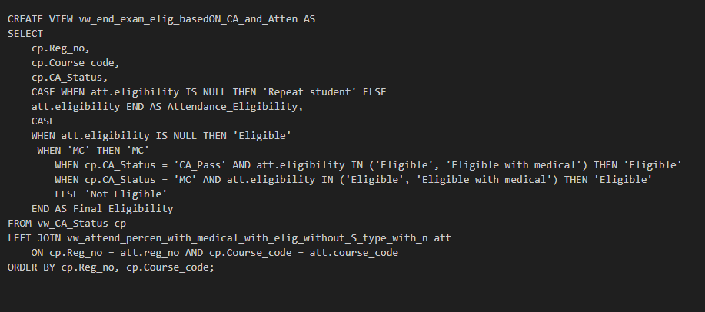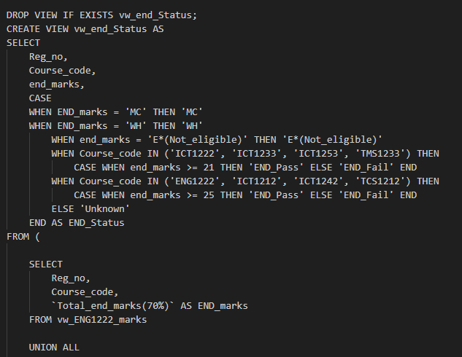
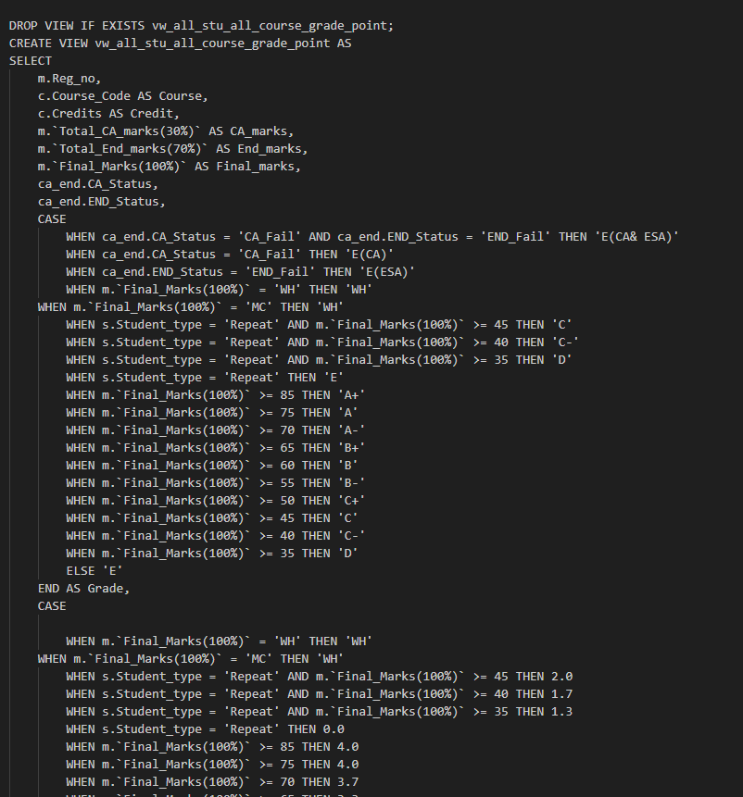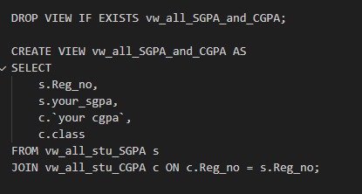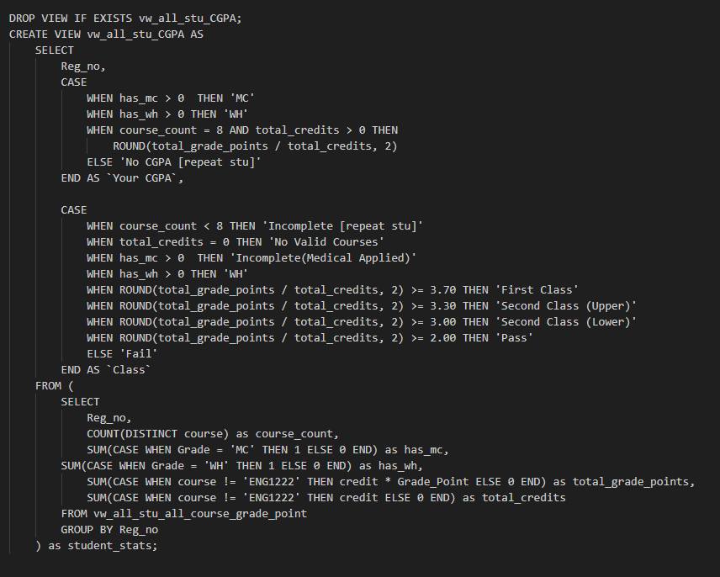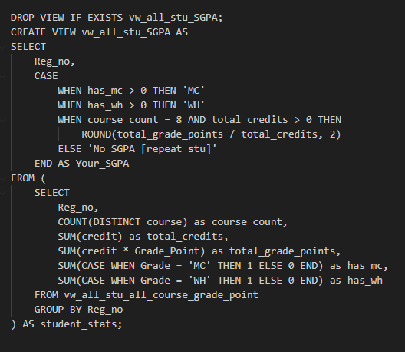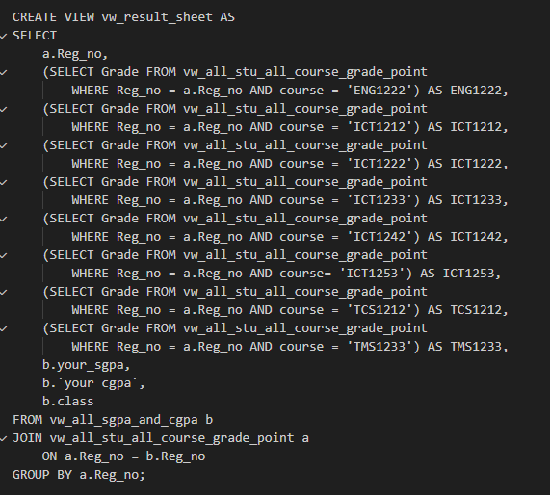

- list of All Procedures

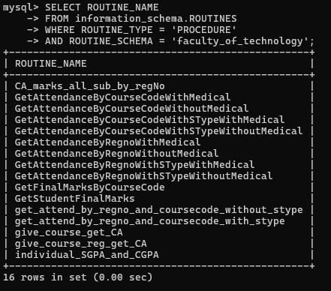

  - procedures
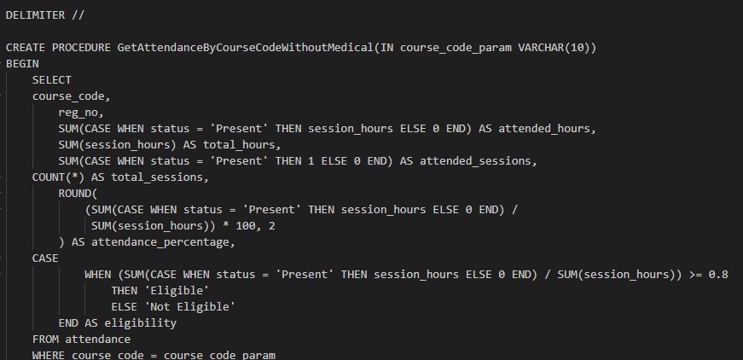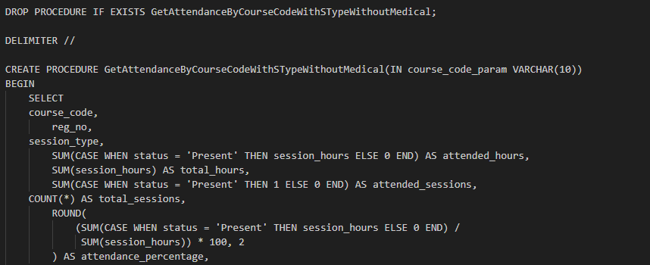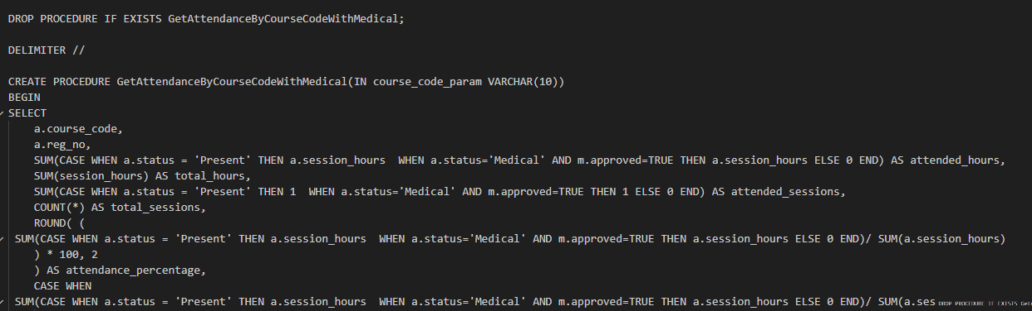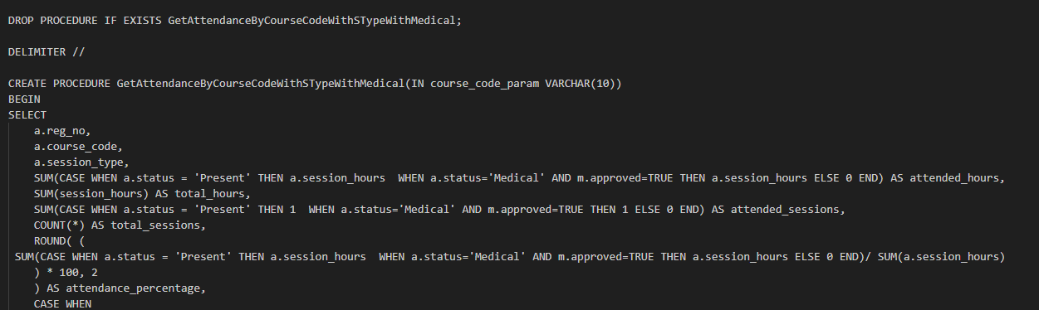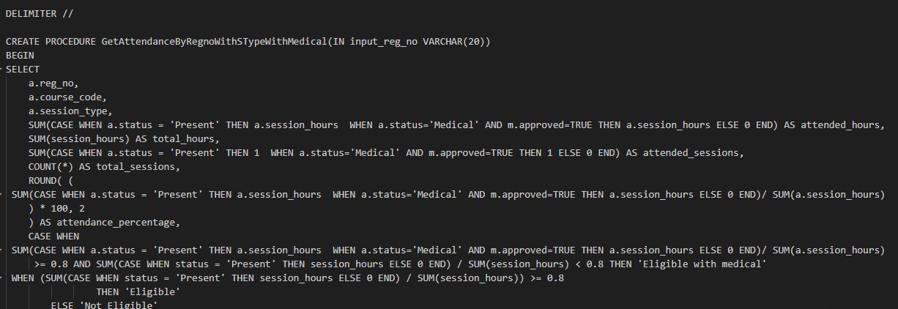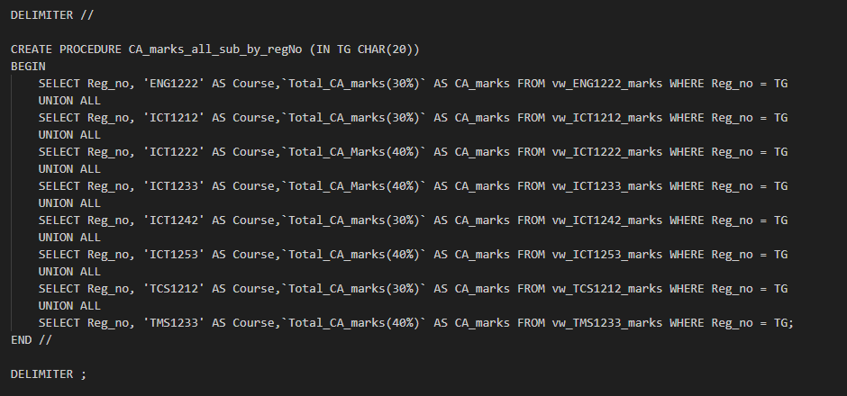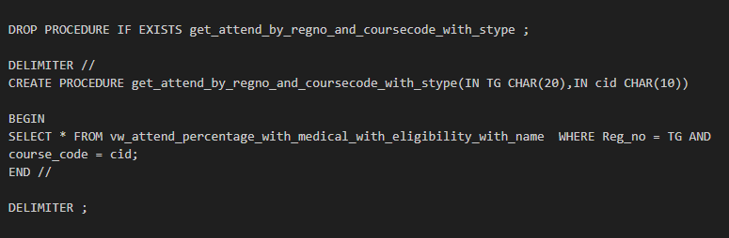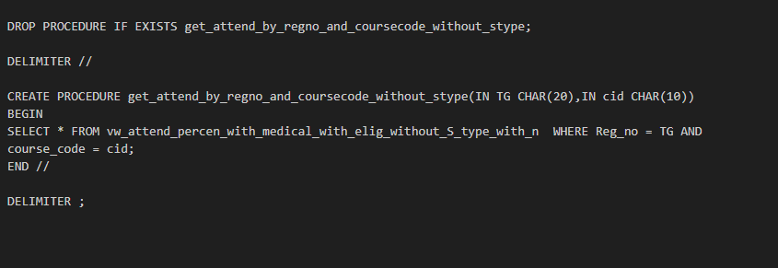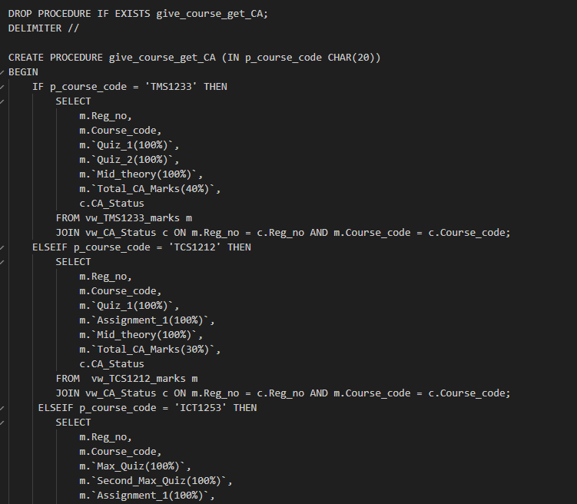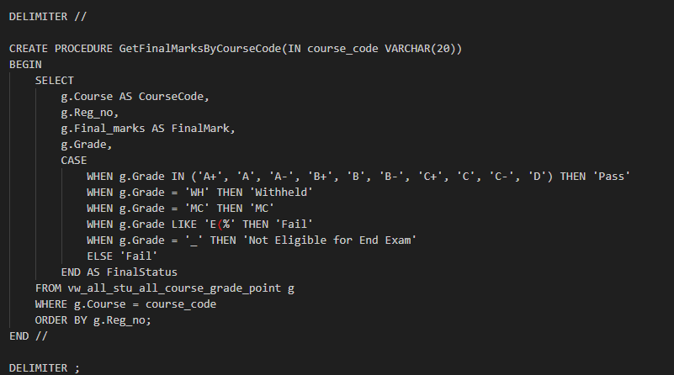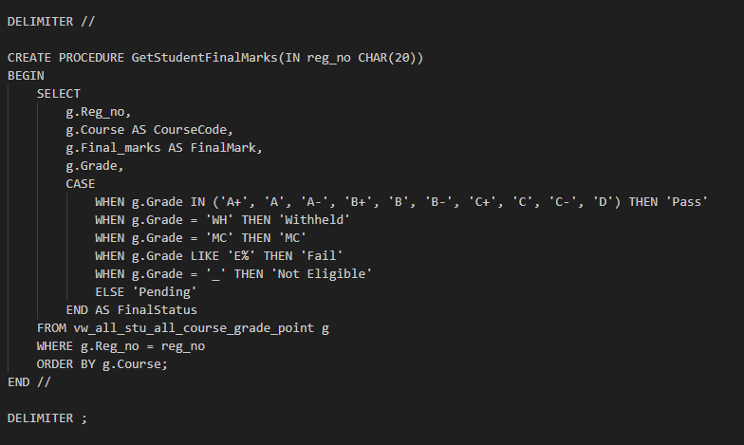

- Queries
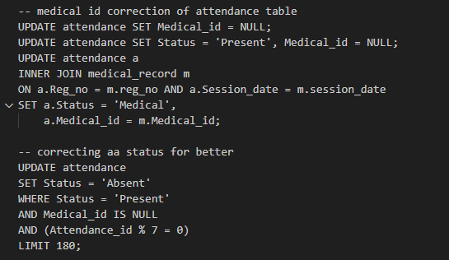

- Problems that were faced during the development of the solution

- Create sample data for every student. It is challenging to create data for 15 weeks because some tables contain thousands of rows.
- Find the correct marks criteria of each course.
- Various types of exams per course.
- Some logics are very complex and difficult to create.
- efficiently collaborate with group members.

- Solutions/how have we overcome the above-identified problems

- Group members create data by sharing. All group members create that data by sharing.
- Examine UGC Commission Circular No. 12-2024 for getting updated with the criteria.
- Normalized database
- Use SQL constraints for data validations.

- Choose a platform for the host database and the reason

I will choose a cloud provider like,
• Amazon Web Services (AWS)
• Microsoft Azure
• Google Cloud Platform (GCP) for the following
Because then,
- Easily increase or decrease server resources
- High Availability
- Provides built-in security features like encryption and access control
- Provide backups
- Can pay only for the resources we use
So, it is a better choice for hosting.

- The things/changes to do for the host database in cloud storage

- Move our MySQL database from the local computer to a cloud database service.

- Change all connection strings in our application to connect to the cloud database

- Set up cloud firewall rules and security groups to control who can access the database.

- Individual contributions
Github Repository Link - git@github.com:dilusharadeeshan/Student-Management-System.git


TG/2023/1721
P.H.T. Sharindi

For my contribution to the database design and development, I created key tables, views, and stored procedures.
Tables & Data Insertion part
- ATTENDANCE – Store each student’s presence details for every course session. The Attendance_id is the Primary Key (PK), which uniquely identifies each attendance record. It includes fields like Reg_no, Course_code, Session_type, Session_hours, Status. The Reg_no, Course_code, and Medical_id act as Foreign Kry (FK) that link this table with student, course, and medical_record tables.( Insert data to attendance table(from 1 week to 5 week))

- MEDICAL_RECORD – Stores the medical information of students who are absent due to health reasons. Primary Key is Medical_id, and it connects back to the attendance table through a foreign key relationship.( Insert data to medical_record table from 08/05 to 08/30 of 2025)

- ENROLL_IN - insert data to enroll in table(006-010)

Views
- vw_eligibi_without_medical_with_name – This SQL view calculates student attendance eligibility for each course and session type, without considering medical leave.
- vw_eligibi_without_medical_with_name_without_s_type – This SQL view calculates student attendance eligibility for each course (ignoring session types), without considering medical leave.
- vw_end_exam_elig_basedon_ca_and_atten – This SQL view determines final eligibility for end-of-semester exam by combining both CA status and attendance eligibility.
- vw_ict1233_marks – This view acts like a grade calculator specifically for the ICT1233 course, showing exactly how each student’s final grade is determined.

- vw_ict1242_marks – This SQL view calculates detailed marks for the ICT1242 course, breaking down quizzes, mid-terms, assignments, and finals
- vw_total_ca_end_status – This SQL view combines CA and End exam eligibility statuses to determine if students’ quality for finals.
- vw_all_sgpa_and_cgpa – This SQL summarizes overall academic performance, showing semester and GPAs with class rankings for each student.
- vw_result_sheet – This SQL displays a complete academic transcript with grades for all courses SGPA and CGPA.
Procedures
- GetAttendanceByCourseCodeWithSTypeWithMedical
- This stored procedure retrieves attendance records for a specific course while considering approved medical leaves. It calculates attendance percentage and eligibility for end exams, where medical absences are counted as present if approved.
- CALL GetAttendanceByCourseCodeWithSTypeWithMedical(‘ICT1242’);

- GetAttendanceByCourseCodeWithSTypeWithoutMedical
- Shows attendance for a course counting only actual “Present” records. Medical leaves are ignored. Determines if students meet the strict 80% requirement for exam eligibility.
- CALL GetAttendanceByCourseCodeWithSTypeWithoutMedical(‘ICT1233’);

- get_attend_by_regno_and_coursecode_with_stype
- Shows one student's detailed attendance for a specific course, broken down by session types (Lecture/Lab). Includes approved medical leaves in the attendance count.
- CALL get_attend_by_regno_and_coursecode_with_stype(‘TG/2023/003’,’ICT1233’);

- CA_marks_all_sub_by_regNo
- Shows all CA marks for one student across every subject in a single report.
- CALL CA_marks_all_sub_by_regNo(‘ICT1242’);

- GetFinalMarksByCourseCode
- Shows final exam results for all students in a specific course, including their marks, grades, and pass/fail status.
- CALL GetFinalMarksByCourseCode(‘ICT1242’);
Users
Admin - With All privileges with Grant Option for all the tables in the database
Dean - With All privileges without Grant for all the tables in the database
Lecturer - All privileges without Grant and user creation for all the tables in the database

TG/2023/1748
R.P.D.Radeeshan

- Created tables
  - User table and subclass tables of it. They are the admin table, dean table, student table, technical_officer table, and lecturer table.
  - Enrollment table for the M-N relationship between the course and the student.

- Created data
  - Created data for the user table, including one dean, one admin, 7 lecturers, 7 technical officers, 15 proper students, and 8 repeat students for the insert user table and subclass of it.
  - Created some data for the enrollment table to cover 5 proper students and all repeat students.
  - Created some data for attendance table for all students to cover 2025/09/08 to 2025/10/10.
  - Created some data for the mark table to cover 5 proper students and all repeat student based on enrollment for the course.
  - Created some data for medical table to cover medical that apply 2025/08/04 to 2025/08/22.

- Created logic
  - Created logic/wrote a query for updating attendance table data for matching medical record table data. By it correct column medical id of the attendance table matches the medical record based on date and regno.
  - Created query to update the attendance table data for attendance percentage matching around 80% percentages.
  - Created query for correct data of mark table to match eligibility for end exam.

- Created views
  - Create a view vw_medicalApplyAttendance to see medical applied attendance.
  - Create a view vw_approvedMedical to see approved medical .
  - Created a view vw_attend_percen_with_medical_with_elig_without_s_type_with_n to look at the attendance percentage with medical approval and eligibility for the end exam without considering the session type, and Created a view vw_attend_percentage_with_medical_with_eligibility_with_name with considering the session type .
  - Created a view vw_eng1222_marks for looking at CA marks details, End marks details, and also final marks details for the subject ‘ENG1222’ .
  - Created a view vw_ict1212_marks for looking at CA marks details, End marks details, and also final marks details for the subject ‘ICT1212’ .
  - Created a view vw_ict1222_marks for looking at CA marks details, End marks details, and also final marks details for the subject ‘ICT1222’ .
  - Created a view vw_ca_status to look at CA marks and CA pass fail status for the whole badge for every course .
  - Created a view vw_all_stu_all_course_grade_point for CA marks, End marks, Final marks, CA status, End status with grade and grade point for the whole batch for all courses.

- Procedures
  - Created procedure GetAttendanceByCourseCodeWithMedical to get attendance with medical aproval with eligibility to whole batch for particular course by giving course code.
  - Created procedure GetAttendanceByRegnoWithSTypeWithMedical to get attendance with medical aproval with eligibility with session type to whole courses by giving reg no .
  - Created procedure give_course_get_CA to get all CA marks details with CA_status by giving course code for whole batch .
  - Created procedure GetStudentFinalMarks to get final marks details with final_status and grade by giving reg no for whole courses .
  - Created procedure get_attend_by_regno_and_coursecode_without_stype to get attendance details with eligibility by giving course code and reg no .

- Users
  - Create a technical officer user with Read, write, and update permissions for attendance-related tables/views like ,
attendance, vw_end_exam_elig_basedon_ca_and_atten, vw_eligibi_without_medical_with_name_without_s_type, vw_attend_percentage_with_medical_with_eligibility_with_name, etc.


TG/2023/1781
H.G.D.I Shadeep

The first part of our project is to draw the er and relational mapping .I also provided my support that. For our Student Management System DBMS Project , I Controbuted by developing portion of the database table , such as mark , course etc… In Addition to this I designed and develop several SQL views and stored procedures.

Table & Data insertion
1. Course - Store information about university courses
2. Mark - The System stores Data releted to the student’s Reg_no ,
course_code and all the exam types they face.
3. Enter the Data releted to the course table.
4. A large amount of data was entered for the enrollment table and some of it has been inserted.
5. furthermore A large amount of data was entered for the Attendance table and some of it has been inserted.
6. A large amount of data was entered for the Medical_record table and some of it has been inserted.
7. Additionaly I was enterd portion of data to mark table .

Views
1. vw_attend_with_medical_approval

provide the session details relevant to the student , that combines data from the attendance and medical_record tables .from this ,we can see whether a students’s medical is approved or not approved .

2. vw_tcs1212_marks , vw_tms1212_marks ,vw_ict1253_marks

This shows the quiz marks , assignment marks , mid marks , end marks , total CA marks , final exam marks , and the overall marks related to each course codes .

3. vw_all_stu_sgpa , vw_all_stu_cgpa
Through these two views , we can obtain in CGPA , CLASS and SGPA for all registration numbers .

Procedures
1.GetAttendanceByRegnoWithMedical , GetAttendanceByRegnoWithoutMedical
These procedures display all the courses related to a specific registration number , showing the attended hours , total hours , attended sessions , attended percentage and eligibility both with and without mecical consideration.

2.GetAttendanceByCourseCodeWithoutMedical
This show all the above details for all students related to a specific course.

3.GetAttendanceByRegnoWithSTypeWithoutMedical
For a given registration number ,show for all enrolled courses the session type , attended hours , total hours , total sessions , attended sessions ,attendance percentage and eligibility .

4.give_course_reg_get_CA
For a student ,after entering their registration number and the relevant course , display the maximum quiz , second maxmum quiz ,assignment mark ,mid mark ,total CA mark and CA status .

5.individual_SGPA_and_CGPA
For a student,after entering their registration number, they can view their CGPA,SGPA, and CLASS.

Users
I created a user (student) and gave permission to only select data from the mark and attendance tables . I also gave the student permission to access the view and procedures related to marks and attendance

- References

- W3Schools. MySQL Tutorial. Available at: https://www.w3schools.com/mysql/
- MySQL Documentation. Official Reference Manual. Available at: https://dev.mysql.com/doc/
- freeCodeCamp. MySQL Tutorials and Guides. Available at: https://www.freecodecamp.org/
- Lecture Notes. Course materials provided by the instructor.

